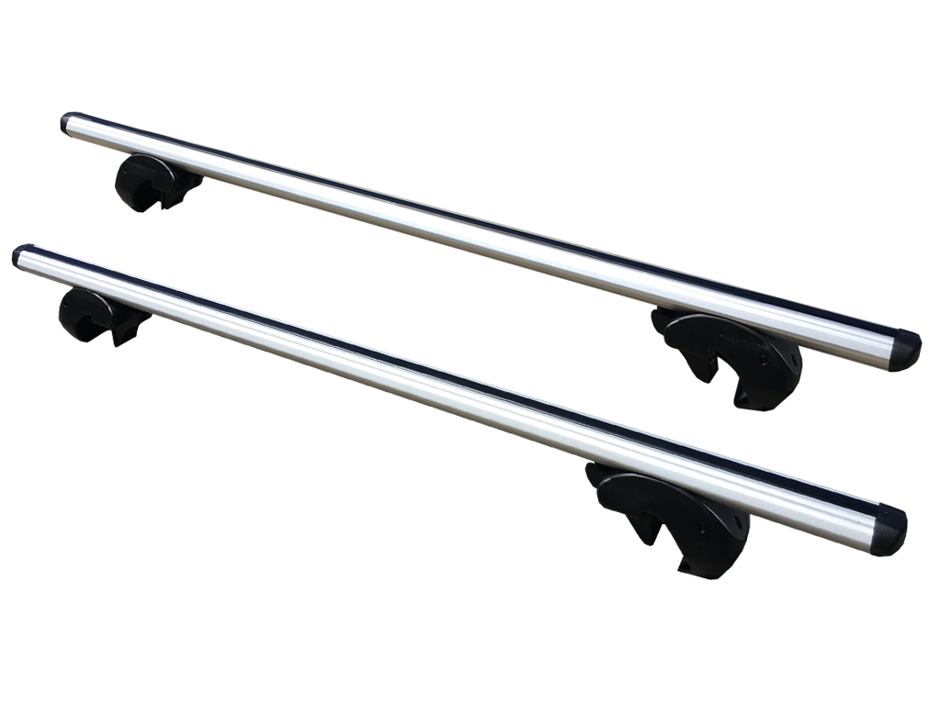
Universal fitting - CARGO BARS (roof racks).

- EXTRUDED ALUMINIUM PROFILE
- ADJUSTABLE LENGTH
- LOCKABLE WITH 2 KEYS INCLUDED
- ALLEN KEY FOR FITMENT INCLUDED
- HEAVY DUTY CLAMPS TO HAVE PLASTIC LINING TO PROTECT CAR ROOF RAILS.

Please Note: These roof racks are suitable ONLY for vehicles and accessories with pre-installed roof rails
These Cargo Bars are longer than most, measuring at a whopping 141cm wide they are fully adjustable. They are suitable for most vehicles and accessories with longitudinal rails. Please ensure you follow all instructions within this document along with the fitting instructions that come with your new cargo bars.
Important Safeguards
* These roof racks are suitable for most vehicles with longitudinal rails.
* To prevent the vehicle/canopy roof from being damaged, it is advisable for 2 people to assemble and install the roof racks.
* The distance between the two racks must be 600mm (unless different instructions are given by the manufacturer).
* Ensure the roof racks do not project pat the side is the vehicle when they are fitted. Trim down the bars if necessary with the appropriate cutting tools.
* The roof racks must be locked onto the longitudinal mounts with the fixing devices and the screw tightened securely with a torque of 6nM.
* The load must be evenly distributed with the lowest possible centre of gravity.
* Before setting out and periodically during a trip, check to make sure the roof racks are still firmly fastened in place. Make sure that all the fixing devises are locked correctly and that the straps that bind the load are tightened and the load has not shifted.
* Where surfboards are carried (or similar items which may produce lifting forces), they shall not be carried side by side, but stacked one on top of the other. All surfboards and similar items shall be secured independently to the front and rear of the vehicle using straps or other methods which are capable of withstanding the lifting forces.
* Equipment must be maintained in good working order.
* The handling characteristics of a vehicle will change when roof racks are fitted especially when it is loaded (in particular, crosswind sensitivity, handling on bends and baking). Driving techniques should be altered to allow for these changes, such as, reducing speed, (especially on bends) and allowing for longer braking distances.
* If ling objects are transported, the ends should also be fixed to the vehicles tow points.
CAUTION: Do not use elastic straps to tie down load.
* It is important to tie the load safely with load applicable non-elastic tie-downs.
* The load must not be heavier that the bearing capacity of the roof as indicated by the vehicle or canopy manufacturer.
* The tolerated bearing capacity comprises the weight of the actual roof racks at 4kg, plus the additional load.
* The bearing capacity of the roof racks (pair) is 90kg.

CAUTION: Do not fit onto roof rails that have a height or width of less than 22mm or greater than 42mm.
* PJ’s 4x4 declines all liability for damage deriving from the vehicle having been driven at a high speed, from having been driven incorrectly or from the roof rack or load having been poorly positioned, fixed or fastened.
* Do no exceed the recommended maximum speed of 110kmph with load applied to the roof racks.
* Not suitable for vehicles where the roof rails are flush with the vehicles roof surface.

